Job Description

Job Title – Health and Safety Co-Ordinator (Estates, Fire & Digital)

Job Description
College/Service  Health and Safety / People Directorate | Location  King’s Cross
Contract Length  Permanent | Hours per week / FTE  21 / 0.6
Accountable to  Head of Health & Safety (Estates, Fire & Digital) | Weeks per year  52
Salary  £36,532.00 - £44,865.00 per annum (pro rata) | Grade  Grade 4
Who are we?
University of the Arts London has an international reputation in art, design, fashion, communication and performing arts. It has approximately 19,000 students from over 130 countries. UAL’s six colleges – Camberwell College of Arts, Central Saint Martins, Chelsea College of Arts, London College of Communication, London College of Fashion and Wimbledon College of Arts – have origins dating back to the mid-19th century. UAL employs around 2500 salaried staff plus our associate and visiting lecturers.

UAL’s estate exceeds 60,000 m2 spread across 15 sites from Wimbledon in South West London to Hackney in the North East. The Estate includes 14 Halls of Residence of Residence. It operates 10 art shops and 17 catering outlets across the estate. The UAL maintenance budget of £11m approximately and manage the facilities maintenance contracts to ensure the buildings are clean and well maintained. As well as an extensive programme of building maintenance works and alterations, UAL is involved in a number of major constructions including building new campus sites for London College of Fashion in Stratford and London College of Communication in Elephant and Castle, and construction of new halls of residence.

The health and safety team are part of the People Directorate reporting to the Chief People Officer. Led by the by the Director of the Health and safety, the team structure includes the Head of H&S (Colleges and Support Services) and Head of H&S (Estates, Fire & Digital).

The team provides a trusted source of expertise and support to the university to
ensure the health and safety of staff and students, and those affected by what we do.

What is the purpose of the role?
We are seeking to appoint a H&S Co-ordinator with fire safety and estate infrastructure experience to support the work of the Health and Safety (Estates, Fire & Digital) team.

Reporting into the Head of Health & Safety (Estates, Fire & Digital), the post holder’s main objectives are to support key functions in matters relating to fire, building and construction safety giving assurances that the built environment is fit for purpose and is compliant with legislative and statutory requirements. This will include student accommodation, retail and catering outlets, academic and administrative buildings and its digital infrastructure.
Working closely with the Health and Safety Estate, Fire & Digital team, they will help to deliver the team’s tasks identified in the Health and Safety Operational Plan.
Duties and Responsibilities
The post holder will:
- Assist with the administration, monitoring and carrying out of fire risk assessments, Estate’s risk assessments, safe systems of work.
- Assist the Health and Safety (Estates, Fire & Digital) team carry out audits and inspections across the estate and help with the reporting and dissemination of reports on findings
- Monitor Fire Safety and Estate incident logs
- Support development and maintenance of the team’s operational plan.
- Support, give advice and help with the delivery of training and toolbox talks to key stakeholders in fire safety and estates safety compliance.
- Support with updating and further developing the Health and Safety management procedures within Estates and Digital teams
- Support with investigations and preparation of reports.
- Have excellent communication to support the preparation of reports for health and safety committees and meetings with key stakeholders.
- Distribute health and safety related meetings and follow up any actions
- Support with health and safety promotional activities and communications
Other Conditions (for senior staff, where appropriate)
- You may be required to regularly travel to other sites as necessary.
- You may be required to work such additional/different hours as may from time to time be necessary for the proper and efficient discharge of duties which may include evenings, Saturdays, Sundays and bank holidays.

General
- To perform such duties consistent with your role as from time to time may be assigned to you anywhere within the University.
- To undertake health and safety duties and responsibilities appropriate to the role.
- To work in accordance with the University’s Equal Opportunities Policy and the Staff Charter, promoting equality and diversity in your work.
- To undertake continuous personal and professional development, and to support it for any staff you manage through effective use of the University’s Planning, Review and Appraisal scheme and staff development opportunities.
- To make full use of all information and communication technologies in adherence to data protection policies to meet the requirements of the role and to promote organisational effectiveness.
- To conduct all financial matters associated with the role accordance to the University’s policies and procedures, as laid down in the Financial Regulations.

Key Working Relationships
Head of Health and Safety (Estates, Fire & Digital)
Health and Safety Team
Director of Estates and their Team
Director of Digital Services and their team at all levels
Contractors and accommodation providers’ health and safety teams

Specific Management Responsibilities

Staff: 0

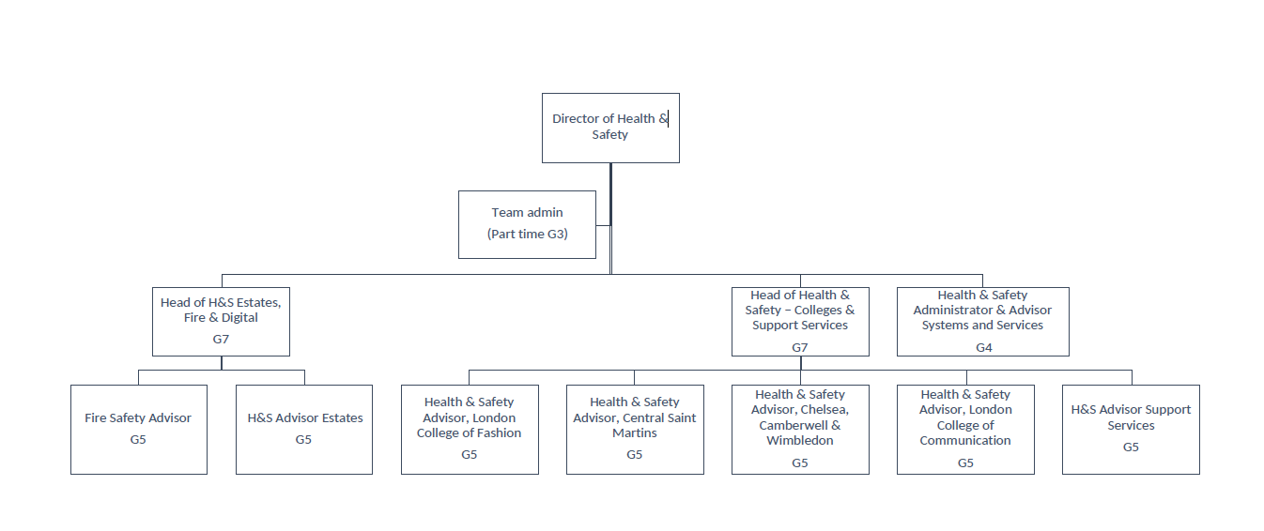

Signed: Gerardina Zeccola

Date of last review: 5 September 2022

Person Specification
Specialist Knowledge/Qualifications | NEBOSH General Certificate in Occupational Health and  Safety (Level 3) or equivalent  Knowledge of Health and Safety regulatory  requirements relating to a large, complex estate, particularly  • Construction Design and Management (CDM)  Regulations  • Fire Safety regulations  • Building Regulations  • Legionella  • Asbestos  • Electricity at Work Regulations  • Management (Health, Safety and Welfare)  Regulations
Relevant Experience | Practical experience of managing health and safety within a relevant industry  Demonstrable experience of development and delivery of health and safety training  Preparation and delivery of high-quality written documents, policies, reports and presentations  Proficient in the use of MS Office applications including Word, Excel, Teams and Office 365 tools
Communication Skills | Communicates effectively orally and in writing adapting the message for a diverse audience in an inclusive and accessible way.
Planning and Managing Resources | Plans, prioritises and manages resources effectively to achieve long term objectives.
Teamwork | Works collaboratively in a team and where appropriate across or with different professional groups.
Student Experience or  Customer Service | Builds and maintains positive relationships with students or customers.
Creativity, Innovation and Problem Solving | Suggests practical solutions to new or unique problem.

Please make sure you provide evidence to demonstrate clearly how you meet these criteria, which are all essential unless marked otherwise. Shortlisting will be based on your responses.
Psychometric testing is included as part of the recruitment process.

